Market Structures Cheat Sheet

(Long and Short Run)

Summary of classification:

* Perfect competition: Perfect competition is a result of numerous small firms competing against each other. Firms in perfect competition produce the socially optimal output level at the minimum possible cost per unit.
* Pure Monopoly: A pure monopoly is a firm that has no competitors in its industry. It reduces supply to drive up prices and increase profit margins. As a result, monopolies produce less than the socially optimal output level and produces at higher costs than competitive firms because competition does not force them to lower costs of production.
* Oligopoly: An oligopoly is an industry with a few competing firms. If they collude, they can reduce output and drive up profits similarly to the way a monopoly does. Because of strong incentives to cheat on collusive agreements, oligopoly firms often end up competing against each other.
* Monopolistic competition**:** In monopolistic competition, an industry contains many competing firms, each of which has a similar but different product. Production costs are above what could be achieved if all the firms sold identical products. They often advertise heavily to market their brand of product as superior to other competitors in their industry.

Real world examples of each firm:

* Perfect Competition: (Agriculture, chemical producers, cotton, cardboard production.)
* Pure Monopoly: (Cable Television, local utilities (if government has blocked entry), pharmaceutical or technological patients on a unique product.)
* Oligopoly: (Airlines, Oil companies, Cellphone companies)
* Monopolistic Competition (Restaurants, Water bottle companies, clothing producers)

Qualities of each firm:

* Perfect competition

# of sellers: Very many

Close substitutes?: Nearly identical substitutes

Ease of entry: Very easy

Price taker or maker: Price taker

* Pure Monopoly

# of sellers: Only 1

Close substitutes?: None

Ease of entry: Near impossible

Price taker or maker: Strong price maker

* Oligopoly

# of sellers: Few

Close substitutes?: Similar products (ex. I phone vs Samsung Galaxy)

Ease of entry: Difficult

Price taker or maker: Hybrid (depends on weather or not firms collude or compete)

* Monopolistic Competition

# of sellers: Many

Close substitutes?: Yes (not perfect substitutes)

Ease of entry: Very Easy

Price taker or maker: Weak price maker (eventually a high enough price will make a product’s demand curve elastic)

Supply and Demand in the Short and Long-Run:

Perfect Competition(Short Run): (supply is very elastic)

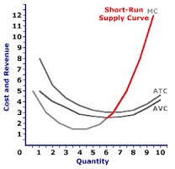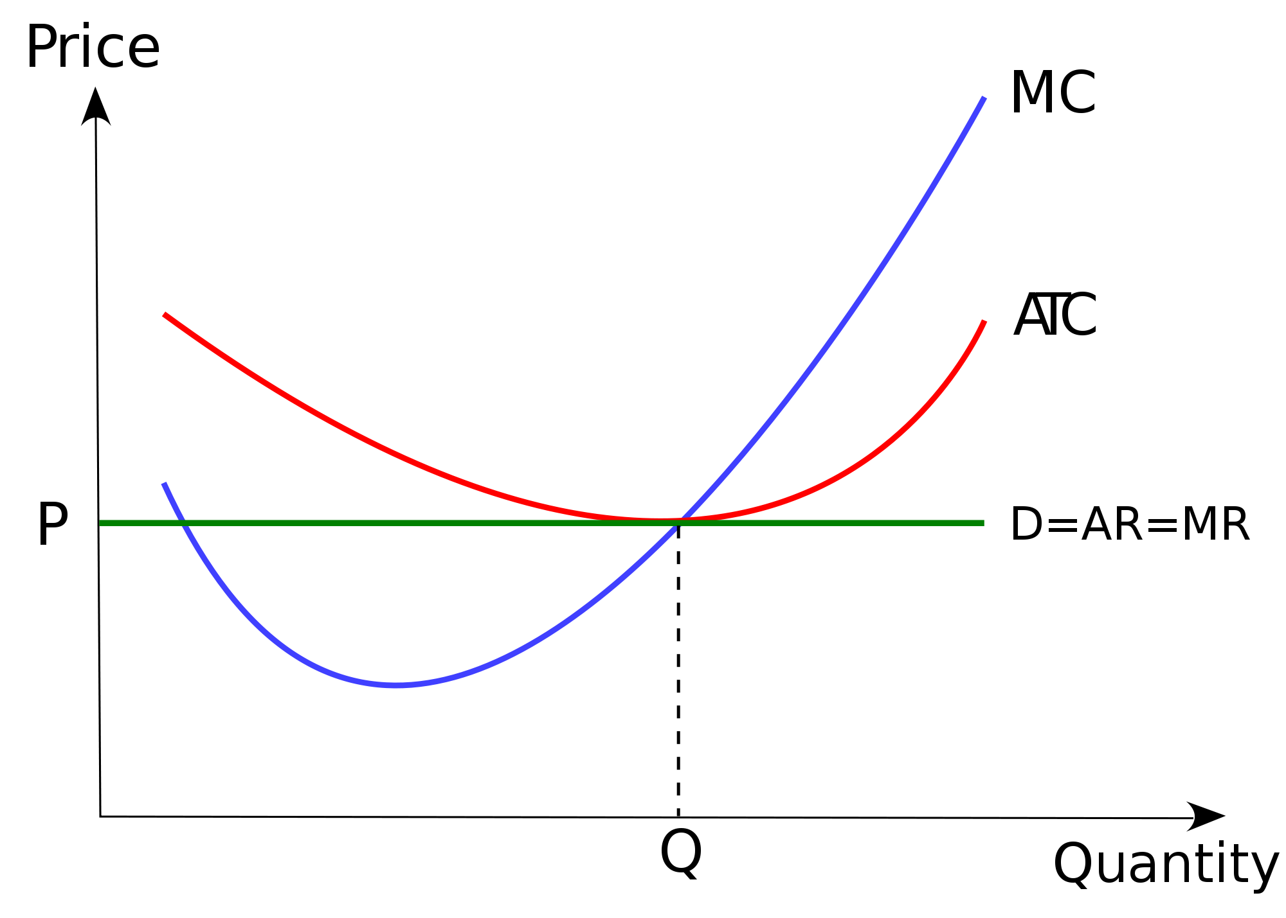

Pure Monopoly(Short Run):

**No Supply curve because a Monopoly has market control(over price) and will produce at quantity where MR=MC, the quantity they decide to produce, however, is not directly a function of the price they decide charge**

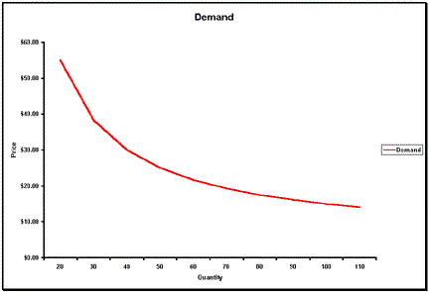

Oligopoly ( Short Run): (supply is pseudo elastic)

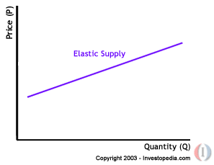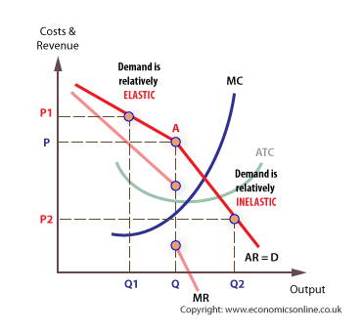

An oligopolist faces a downward sloping demand curve but the elasticity may depend on the reaction of rivals to changes in price and output. Assuming that firms are attempting to maintain their market share:

1. rivals will not follow a price increase by one firm - therefore demand will be relatively elastic and a rise in price would lead to a fall in the total revenue of the firm

2. rivals are more likely to match a price fall by one firm to avoid a loss of market share. If this happens demand will be more inelastic and a fall in price will also lead to a fall in total revenue.

This discontinuity in demand outcomes is the cause of the kink in an Oligopolies demand curve.

Monopolistic Competition (Short Run):

No Supply curve, the small amount of market control by a monopolistically competitive firm means that its' price is NOT equal to marginal revenue, and thus it does NOT equate marginal cost and price. A monopolistic competition does not necessarily supply larger quantities at higher prices or smaller quantities at lower prices.

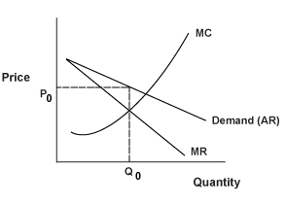

Long Run

(All supply is more elastic in the long run)

Perfect competition (Long Run):

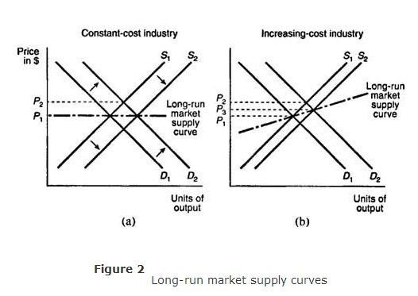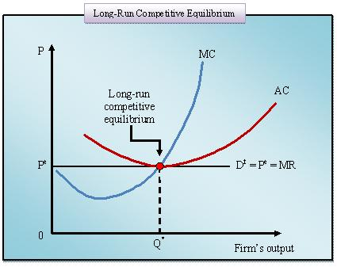

Pure Monopoly(Long Run):

No supply curve because of monopoly

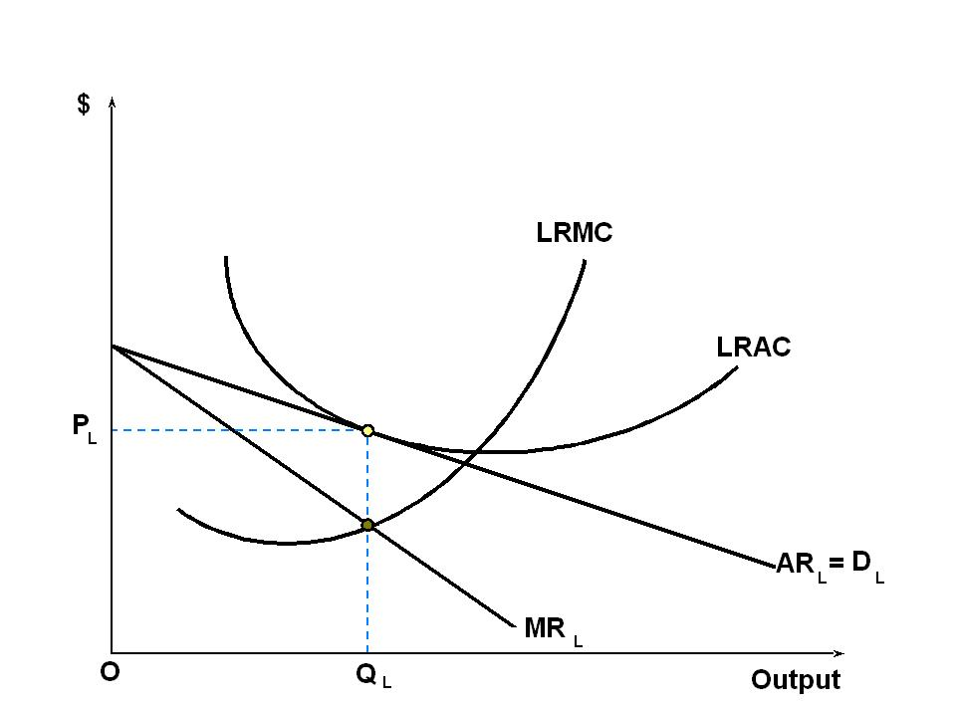

Oligopoly ) Long Run):

Demand is same as in the short run because Oligopolies know that if they lower prices, their competitors will match the cut and if they raise price they will sell less quantity and earn lower total revenue.



Monopolistic Competition (Long Run):

